**Madhya Pradesh**

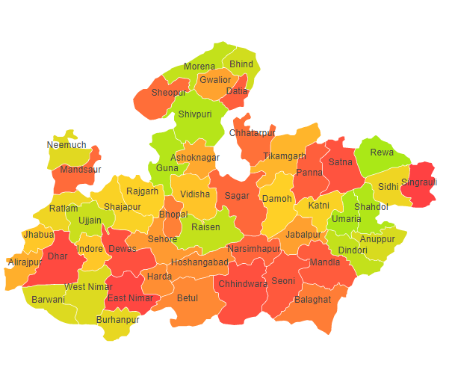

Madhya Pradesh comprises of three Agro Ecological Regions (AER) 4, 5 & 10.

**Agro-Eco Region 4:** AER 4 in Madhya Pradesh comprises of Bhind, Datia, Gwalior, Morena, Sheopur and Shivpri districts of Northern Plain and Central Highlands including Aravallis under Agro Ecological Sub Regions (AESR) 4.3 & 4.4.

**Agro-Eco Region 5:** AER 5 in Madhya Pradesh comprises of Alirajpur, Barwani, Burhanpur, Dewas, Dhar, East Nimar, Indore, Jhabua, Mandsaur, Nimach, Ratlam, Shajapur, Ujjan and West Nirman districts of Central (Malwa) Highlands under Agro Ecological Sub Region (AESR) 5.2.

**Agro-Eco Region 10:** AER 10 in Madhya Pradesh comprises of districts Anuppur, Ashoknagar, Balaghat, Betul, Bhopal, Chhatarpur, Chhindwara, Damoh, Dewas, Dindori, Guna, Harda, Hoshangabad, Jabalpur, Katni, Mandla, Narshimapura, Panna, Raisen, Rajgarh, Rewa, Sagar, Satna, Sehore, Seoni, Shajapur, Shahdol, Sidhi, Singrauli, Tikamgarh, Umaria and Videsha of Central Highlands under Agro Ecological Sub Regions (AESR) 10.1, 10.2 ,10.3& 10.4.